PRODUCT INFORMATION

1. About Us

Introducing Eyeonic: The Visionary Retailer

Welcome to Eyeonic, your premier destination for all things eyewear. Founded just five years ago, we have quickly established ourselves as a leading retailer in the industry, with five conveniently located stores.

At Eyeonic, we understand the power of vision and the importance of finding the perfect eyewear to suit your unique style and needs. Our mission is to provide exceptional quality, unparalleled selection, and outstanding customer service, ensuring that every customer walks away with a truly satisfying experience.

With a team of knowledgeable and passionate eyewear experts, we strive to stay ahead of the latest trends and offer a diverse range of eyeglasses, sunglasses, and accessories. Whether you're looking for a timeless classic or a cutting-edge design, our extensive collection features a wide array of styles, colors, and materials to cater to every individual taste.

What sets Eyeonic apart is our commitment to quality. We partner with renowned brands and trusted manufacturers, ensuring that every product we offer meets the highest standards of craftsmanship and durability. Your satisfaction and visual well-being are our top priorities, which is why we also provide comprehensive eye exams and personalized fittings to ensure the perfect fit and optimal vision correction.

As a company deeply rooted in the communities we serve, we take pride in giving back. We actively support local charities and initiatives, aiming to make a positive impact on the lives of those around us. At Eyeonic, we believe that clear vision goes beyond eyewear – it's about seeing the world with clarity and compassion.

We invite you to visit any of our five locations and experience the Eyeonic difference for yourself. Our dedicated team is eager to assist you in finding the perfect pair of glasses that not only enhances your vision but also reflects your unique personality. Discover a new perspective with Eyeonic – where vision meets style.

Note: Please ensure to adapt the introduction to fit the specific details and characteristics of your eyewear retail company, Eyeonic.

1. Product List

1.Eyeglasses

Framed glasses are classified into two types: regular glasses and sunglasses. Sunglasses help limit the harmful effects of sunlight on the eyes, limit UV rays and help reduce eye fatigue when going in the sun. Glasses are often used to protect the eyes from agents: dust, blue light or can replace lenses with suitable resolution to correct refractive errors such as nearsightedness, farsightedness, astigmatism, amblyopia.

* 1. **Metan**

**Burberry 11**

Type: Eyesglasses

Material: Metal

Color: Yellow

Shape: Cateye

Brand: Burberry

Price: 4.050.000 ₫

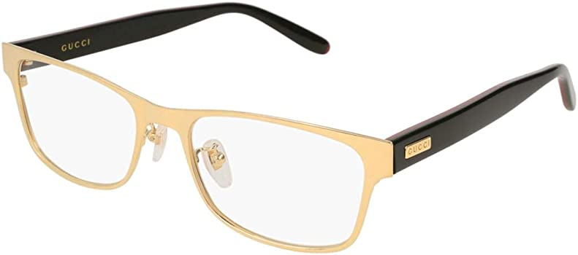

**Burberry 219**

Type: Eyesglasses

Material: Metal

Color: Pink

Shape: Circle

Brand: Burberry

Price: 4.910.000 ₫

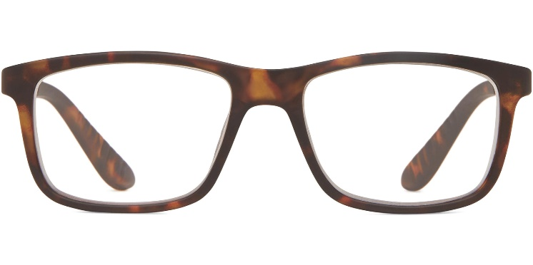

**Burberry 363**

Type: Eyesglasses

Material: Metal

Color: Brown

Shape: Oval

Brand: Burberry

Price: 3.460.000 ₫

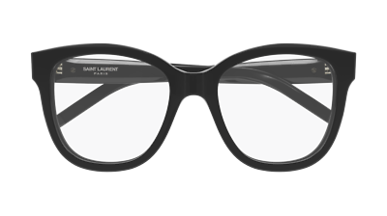

**Burberry 402**

Type: Eyesglasses

Material: Metal

Color: White

Shape: Square

Brand: Burberry

Price: 5.350.000 ₫

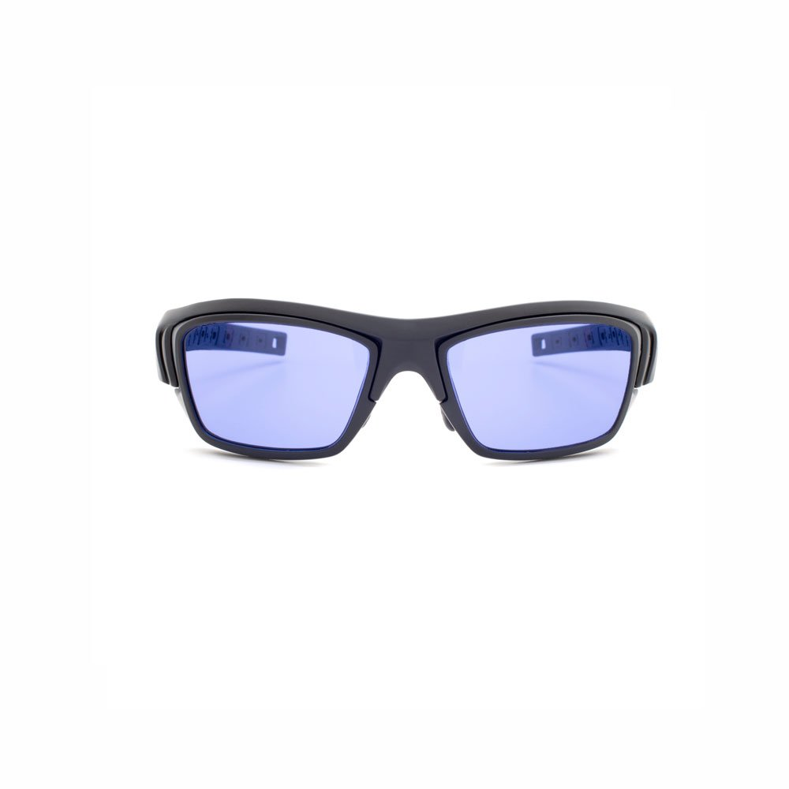

## Rayban 38

Type: Eyesglasses

Material: Metal

Color: Brown

Shape: Oval

Brand: Rayban

Price: 5.350.000 ₫

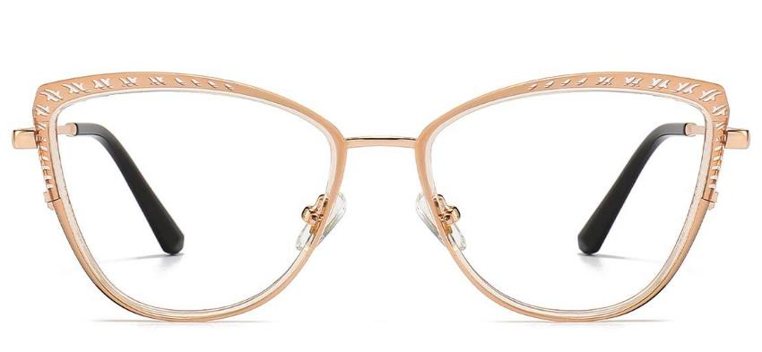

## Rayban 83

Type: Eyesglasses

Material: Metal

Color: Black

Shape: Oval

Brand: Rayban

Price: 3.550.000 ₫

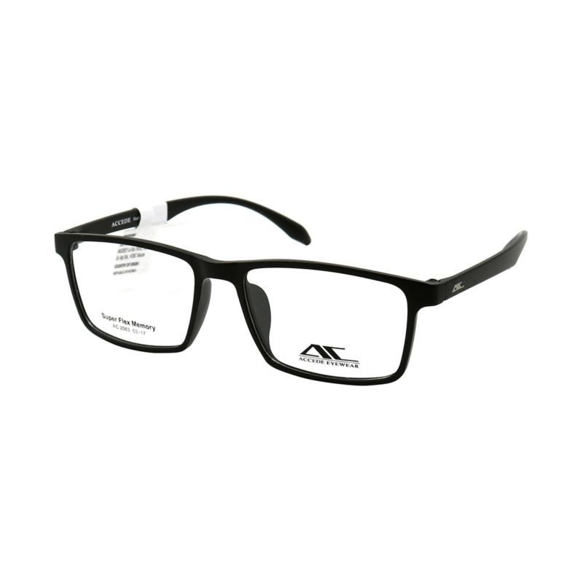

## Rayban 146

Type: Eyesglasses

Material: Metal

Color: Yellow

Shape: Cateye

Brand: Rayban

Price: 5.690.000 ₫

